Worksheet 1 - Boolean algebra

1. Complete the following table, the first one is completed for you for illustration:

|  |  |  |
| --- | --- | --- |
| **Logic Gate** | **Symbol** | **Truth Table** |
| AND |  | |  |  |  | | --- | --- | --- | | A | B | Y | | 0 | 0 | 0 | | 0 | 1 | 0 | | 1 | 0 | 0 | | 1 | 1 | 1 | |
|  |  | |  |  |  | | --- | --- | --- | | A | B | Y | | 0 | 0 | 0 | | 0 | 1 | 1 | | 1 | 0 | 1 | | 1 | 1 | 1 | |
|  | [http://www.bbc.co.uk/staticarchive/f0a2797c09c4ca7f456edf2c2b27d587c9f5abab.gif](http://www.google.co.uk/url?sa=i&rct=j&q=&esrc=s&source=images&cd=&cad=rja&uact=8&ved=0CAcQjRxqFQoTCKf4kMvKlckCFUJSFAodMR4P4w&url=http://www.bbc.co.uk/schools/gcsebitesize/design/electronics/logicrev3.shtml&psig=AFQjCNGagS9-1l2tRP9ptGb_c8e_8iD_Iw&ust=1447785276146673) | |  |  | | --- | --- | | A | Q | | 0 | 1 | | 1 | 0 | |
|  |  | |  |  |  | | --- | --- | --- | | A | B | C | | 0 | 0 | 0 | | 0 | 1 | 1 | | 1 | 0 | 1 | | 1 | 1 | 0 | |

|  |  |  |  |
| --- | --- | --- | --- |
| R | S | T | X |
| 0 | 0 | 0 | 0 |
| 0 | 0 | 1 | 0 |
| 0 | 1 | 0 | 0 |
| 1 | 0 | 0 | 0 |
| 1 | 0 | 1 | 0 |
| 1 | 1 | 0 | 1 |
| 0 | 1 | 1 | 1 |
| 1 | 1 | 1 | 1 |
|  |  |  |  |

1. An electronic system will only operate if three switches R, S and T are correctly set. An output signal (X = 1) will occur if R and S are both in the ON position **or** if R is in the OFF position and S and T are both in the ON position.
2. **Draw a logic circuit** to represent the above situation.
3. **Produce truth table for the above circuit.**
4. **Use online simulator to simulate the circuit and test it using appropriate inputs. Note: The link for the online simulator is** [**https://logic.ly/demo/**](https://logic.ly/demo/)

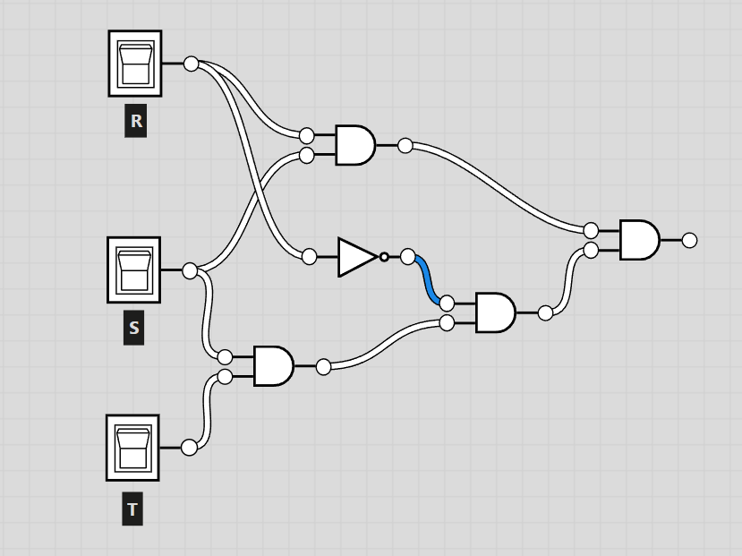

1. A chemical process gives out a warning signal (W = 1) when the process operates incorrectly. A logic circuit (network) is used to monitor the process and to determine whether W = 1.

|  |  |  |
| --- | --- | --- |
| Input | Binary Value | Description of plant Status |
| C | 1 | Chemical rate = 20 litres/second |
| 0 | Chemical rate < 20 litres/second |
| T | 1 | Temperature = 91ºC |
| 0 | Temperature > 91ºC |
| X | 1 | Concentration > 5M |
| 0 | Concentration = 5M |

A warning signal (W = 1) will be generated if:

either:

(a) Chemical rate < 20 litres/second

Or

(b) Temperature > 91ºC and Concentration > 5M

or

(c) Chemical rate = 20 litres/second and Temperature > 91C

(i) Draw a logic circuit (network) and truth table to show all the possible situations when the warning signal could be received.

**(ii) Use the online simulator,** [**https://logic.ly/demo**](https://logic.ly/demo) **, simulate the circuit and test it using appropriate inputs.**

1. For the following circuits:
   1. write the Boolean expression
   2. produce truth table

|  |  |  |  |
| --- | --- | --- | --- |
| Circuit | Truth Table | | Expression |
|  | |  |  |  |  | | --- | --- | --- | --- | | **A** | **B** | **C** | **x** | | 0 | 0 | 0 |  | | 0 | 0 | 1 |  | | 0 | 1 | 0 |  | | 0 | 1 | 1 |  | | 1 | 0 | 0 |  | | 1 | 0 | 1 |  | | 1 | 1 | 0 |  | | 1 | 1 | 1 |  | |  |  |  |  | | | X= |
| Logic Circuits - Computer Science GCSE GURU | |  |  |  | | --- | --- | --- | | A | B | z | | 0 | 0 |  | | 0 | 1 |  | | 1 | 0 |  | | 1 | 1 |  | | | z = |
| c. Use online simulator <https://logic.ly/demo> to simulate the circuits and test them by applying all different inputs and compare the output.  d. For the following circuit write the Boolean exopression only: | | | |
| Circuit | | Expression | |
| https://6004.mit.edu/currentsemester/tutprobs/gates07.gif  For this circuit, write the expression ONLY. | | Q = | |
|  | | Q = | |